Question 3.

One of the registration websites requires your suggestion on the Usability aspects of their website. Provide your feedback/improvements/suggestions as a Functional Quality Engineer and as an End - User in terms of Functionality Usability UI Aesthetics.

* First of all, the website is not opening in the laptop/desktop it is opening in the mobile so first it needs to compatible with different screens, platforms, width, length of the website.
* The UI is too old, so there should be an easiest way to fill up the form and also there should be navigations in the form from one page to another rather than everything in the one page.
* It should provide a proper login/Signup Methods for the form fill up.

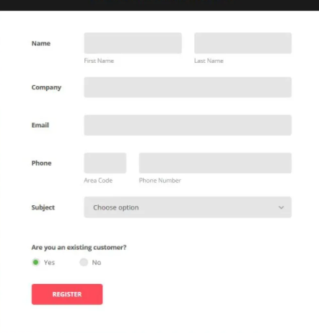

Example of sample form picture.

* Dcouments should be keep safely in the new page rather than keeping it one page.